Project Management Plan
Intelligent Work Management

Presented to:

Sonalysts

January 10, 2011

Kenneth M. Levine, Chris Duffy, Michael Peter
407-299-3900
MasterLink Corporation
3649 All American Boulevard
Orlando, Florida 32810

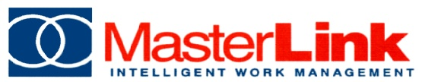
Revision History
Version Number | Date | Description | Author
0.01 | 11/1/2010 | Initial Draft | Ken Levine, Chris Duffy
0.02 | 12/1/2010 | Sonalysts Updates | Ken Levine
0.03 | 12/28/2010 | Sonalysts Updates and feed back | Michael Peter
0.04 | 1/7/2011 | Sonalysts Updates and feed back | Michael Peter
0.05 | 1/10/2011 | Sonalysts Updates and feed back | Michael Peter
Distribution
Recipient Name | Recipient Organization | Distribution Method
Beth Giurelli | Sonalysts, Inc | Soft Copy
Plan Approvers
Approver Name | Approver Signature | Approval Date | Approval Organization
Beth Giurelli
Michael Peter

Configuration of this Document
This document is under full configuration management.

Contents
1. Overview 3
1.1. Project Overview, Objectives and Success Criteria 3
1.2. Scope 4
1.3. Out of Scope 4
1.4. Project Deliverables 4
1.5. Project Management Plan Updates 5
2. Project Organization 6
2.1. Organization Structure 6
2.2. Organizational Boundaries and Interfaces 6
2.3. Roles & Responsibilities 7
3. Management Process 8
3.1. Assumptions, Dependencies, and Constraints 8
3.2. Risk Management 8
3.3. Project Monitor and Control 9
3.4. Communication Plan 10
4. Technical Process 11
4.1. Requirements Capture 11
4.2. Design and Coding 16
4.3. Tools 17
4.4. Configuration Management Plan 18
5. Testing 20
5.1. Unit Testing 20
5.2. Agent Testing 20
5.3. System Testing 20
5.4. User Acceptance Testing 20
5.5. Defect Resolution 21
Appendix A – Risk List 22

Overview
The Marines have a need to apply systematic, automated control to the maintenance process for Marine vehicles in order to facilitate vehicle readiness. This project will enhance an existing work management system to meet that need.

Project Overview, Objectives and Success Criteria
The purpose of the TO12 project is to utilize the functionality of MasterLink’s software product, Intelligent Work Management (IWM), to create an application to meet the needs of the vehicle maintenance schedulers and mechanics of the Mine Resistant Ambush Protected (MRAP) vehicle program.

The TO12 project team is composed of Sonalysts, Inc., serving as prime contractor, and MasterLink, Corp serving as sub-contractor. Key stakeholders for the project are outlined in the following table.

Table 1: Key Stakeholders
Stakeholders | Internal / External | Description
Government Technical Point-of-Contact (TPOC) | External | Government liaison to TO12. Project oversight, steering, and government representation. Includes coordination with the Sonalysts project manager.
MRAP Vehicle Maintenance Managers | External | Subject Matter Experts: Management –level users of the TO12 IWM system. Includes Maintenance Management Officers (MMOs).
MRAP Vehicle Maintenance Workers | External | Subject Matter Experts: Worker-level users of the TO12 IWM system. Includes mechanics, technicians and others as designated.
Sonalysts Executives | Internal | Prime contractor executive personnel assigned to or assisting with the TO12 project.
Sonalysts Project Manager | Internal | Prime contractor representative with overall project oversight, steering, and management duties. Includes coordinating with both the government TPOC and MLC project manager.
MLC Executive Team | Internal | Sub-contractor executive personnel assigned to or assisting with the TO12 project.
MLC Project Manager | Internal | Sub-contractor representative with development project oversight, steering, and management duties. Includes coordination with the Sonalysts Project Manager

Objectives
The TO12 project will successfully deliver an IWM system to automate planning, scheduling, access to and tracking of MRAP maintenance and repair work at the vehicle maintenance facility. IWM will provide specific views and reporting to facilitate transparency into each vehicle’s maintenance and readiness as well as the overall state of the vehicle maintenance process.

Specific objectives and success criteria as relevant to the key stakeholders are captured in the following table.

Table 2: TO12 Project Objective & Success Criteria
Objective | Stakeholder | Success Criteria | Measurement
Successful delivery of IWM system | All | Completion of deployable system | Code and test complete by September 1, 2011.

Additional criteria on system functionality are captured in the Software Requirements Document.

Scope
The project involves modification of an existing software application, IWM, to provide the following enhancements:

- Scheduling of workers, parts from inventory, and other resources to preventative and corrective maintenance jobs.
- Customization of the manager and worker screens to support the MRAP maintenance facility workflow

Out of Scope
The following work is outside of the scope of this project:

- Classroom or training-based scheduling
- Training, operations and maintenance at the MRAP vehicle maintenance facility

Project Deliverables
Below is a list of the project deliverables to be presented by MasterLink to Sonalysts and the government TPOC for W62.

Table 3: TO12 Project Deliverables
Deliverable | Recipients | Delivery Date | Delivery Method
Project Management Plan | Sonalysts | January 2011 | Soft copy
Project Work Plan | Sonalysts | January 2011 | Soft copy
Interim Progress Report 1 | Sonalysts, TPOC | January 2011 as required by government | Soft copy
Software Requirements Document | Sonalysts, TPOC | 4/22/2011 | Soft copy
Interim Progress Report 2 | Sonalysts, TPOC | June 2011 as required by government | Soft copy
Final Report | Sonalysts, TPOC | 9/15/2011 | Soft copy

Project Management Plan Updates
The Project Management Plan is intended to be generated once for the project to serve as a charter for what the work comprises and how the work is to be done. The Project Work Plan will be updated throughout the project.

A copy of the PMP can be found on the TO12 Project Site.

Project Organization
The project team for TO12 is composed of two teams: a management/design team from Sonalysts and a development team from MasterLink. This section describes the project organizational structure, identifies organizational boundaries and interfaces, and defines individual responsibilities.

Organization Structure
The following chart depicts the organizational structure and key project personnel.

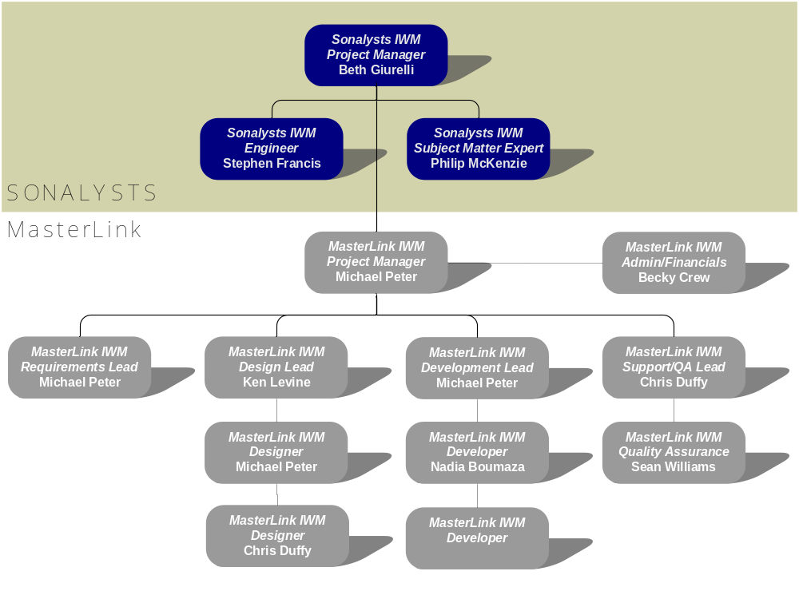
Figure 1: TO12 Organizational Structure and Personnel

Organizational Boundaries and Interfaces
Government/Navy – Sonalysts: The communication link between the government/military and Sonalysts is maintained through the government TPOC, Shannon Foley, and the Sonalysts IWM Project Manager, Beth Giurelli.

Sonalysts – MasterLink: Coordination of Sonalysts and MasterLink activities for TO12 is done through the Sonalysts IWM Project Manager, Beth Giurelli, and the MasterLink IWM Project Manager, Michael Peter.

Sonalysts – MRAP Vehicle Maintenance SMEs: Communication and requirements facilitation with the staff of the MRAP vehicle maintenance facility is the responsibility of the Sonalysts IWM Subject Matter Expert and the Sonalysts IWM Engineer.

MasterLink – MRAP Vehicle Maintenance SMEs: Communication and requirements facilitation with the staff of the MRAP vehicle maintenance facility is the responsibility of the MasterLink IWM Designers, Michael Peter and Chris Duffy.

Roles & Responsibilities
During the course of the TO12 project, the Sonalysts and MasterLink team adhere to the roles defined in Table 4:

Table 4: TO12 Project Roles & Responsibilities
Role | Responsibility
Sonalysts IWM Project Manager | TO12 project management  Interface with the government counterparts/TPOC  Sonalysts interface to the MasterLink IWM project manager
Sonalysts IWM Engineer | User interface design consultation
Sonalysts IWM Subject Matter Expert/SME | Consultation as MRAP vehicle maintenance SME  Liaison to MRAP vehicle maintenance facility staff/SMEs
MLC IWM Project Manager | TO12 project management  MLC interface to the Sonalysts IWM project manager
MLC IWM Administrator/Financials | TO12 human resources  TO12 project financials management  TO12 project status and financials reporting
MLC IWM Requirements Lead | Primary Object-Oriented/UML requirements analyst  Requirement gathering coordination
MLC IWM Design Lead | Primary Object-Oriented/UML designer  Design team coordination
MLC IWM Designer | Object-Oriented/UML design specialist
MLC IWM Development Lead | Primary Java developer/technical lead
MLC IWM Developer | Java developer/technical designer
MLC IWM Support/Quality Assurance Lead | Development support  Quality Assurance team coordination  Test case/test script  System testing
MLC IWM Quality Assurance | Test case/test script development  System testing

Management Process
This section describes the TO12 project assumptions, dependencies, and constraints, risk management techniques, monitoring and control practices, staffing plan, communication plan, and escalation procedures.

Assumptions, Dependencies, and Constraints
The TO12 project is built upon the following assumptions and dependencies, and must work within the following constraints.

Assumptions
- AS-001: Initial requirements will be gathered against the expertise of the Sonalysts IWM SME
- AS-002: User interface design will be performed by Sonalysts engineers
- AS-003: All development tasks, including user interface implementation, will be done by MLC developers

Dependencies
- DE-001: Requirements refinement to be gathered during an on-site visit to Camp Lejeune

Constraints
- CO-001: The requirements and design completion date is fixed to 4/22/2011
- CO-002: The code and test completion date is fixed 8/30/2011
- CO-003: The final report completion date is fixed to 9/15/2011

Risk Management
Risk factors for the TO12 project are documented in a risk management spreadsheet as factors are identified through meetings or task execution. The risk factor spreadsheet is reviewed and risk factor action status updated during the MasterLink daily project status meeting. Two examples are defined in Appendix A. The layout is described below in Table 6. The current risk matrix can be accessed on the TO12 Project Site.

Table 6: Risk Management Spreadsheet
Risk Item | Consequence | Likelihood (1-10 scale) | Priority (1-10 scale) | Impact | Mitigating Action | Responsible Party | Completion Date | Action Status

Risks are discussed during the monthly meetings with Sonalysts to communicate awareness of the current project risks. For each risk factor, mitigating actions are determined, assigned, and communicated.

Project Monitor and Control
The Project Management Plan is executed and tracked through several mechanisms: the Project Work Plan, the monthly Sonalysts project review meeting, daily MLC development status meetings, the risk list, issue list, and associated defect tracking. The Project Work Plan, the issue list and defect tracking are discussed in this section. The meetings are discussed in section 3.4, Communication Plan. The risk list is discussed in section 3.2, Risk Management.

Project Work Plan
The Project Work Plan is created by the MLC Project Manager. The PWP details all deliverables, meetings, and all development tasks in detail. Every task has an owner, and every task has an ending point. Completion percentages on each task are tracked during the course of the project.

The PWP also provides a top level task view to facilitate status reporting: Requirements analysis, design, code and implementation, testing, meetings, and deliverables (as defined in section 1.4, Project Deliverables).

The project plan will be submitted to Sonalysts in Microsoft Project format. A copy of the current PWP can be found on the TO12 Project Site. A project plan thumbnail is illustrated in Figure 2.

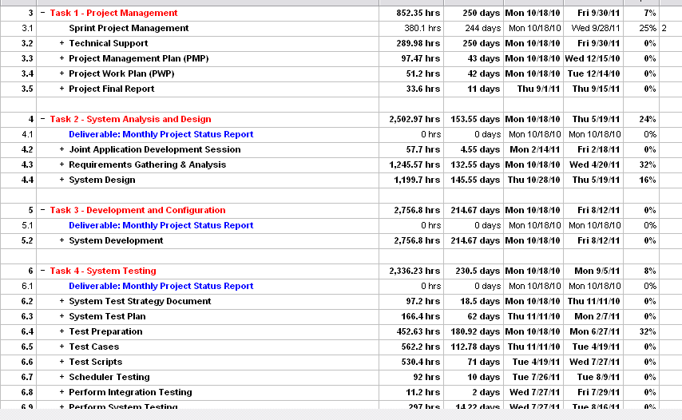
Figure 2: TO12 Project Work Plan

Issue List and Defect Tracking
A TO12 issue list is contained in the MLC ticketing system, Trac, alongside the defect list for the TO12 application code. An issue is a risk that has actually occurred.

Issues are recorded in the same way as defects - they have a reporter and an owner, and are tracked until they are closed, indicating that the issue has been resolved. The issue/defect resolution process completes with retesting/review, where the defect is assigned back to the reporter for acceptance testing or final confirmation of resolution.

Communication Plan
The type and frequency of communication to be used during the project are divided according to the schedule described in Table 7.

Table 7: TO12 Communication Schedule
Type of Communication | Communication Schedule | Communication Mechanism | Who Initiates | Recipient
TO12 Interim Project Reviews | January 2011 & June 2011 as specified by the government | Presentation meeting | Sonalysts Project Mgr | Government TPOC & review board
TO12 Status Report | 3rd of every month | Email | MLC Project Mgr | Sonalysts Project Mgr
TO12 Effort Tracking and Financial Report | 3rd of every month | Email | MLC Administrator | Sonalysts Project Mgr
Sonalysts Project Review | Monthly | Conference call | Sonalysts Project Mgr/MLC Project Mgr | Project Teams
SME/User reviews | As needed | Meeting/phone calls/emails as appropriate | Sonalysts Engineer/MLC Designer | MRAP vehicle maintenance SMEs
MLC Development Status | Daily | Conference call | MLC Project Mgr | MLC Team
Risk Mitigation | As mitigation actions are completed | Email and meetings | Responsible team member | Sonalysts Project Mgr/MLC Project Mgr

Technical Process
MLC uses an agile development methodology. Tasks are broken up into two week sprints, and while the overall requirements and direction is understood before main development begins, many detail oriented requirement and detail design artifacts are not generated until they are needed. This allows for requirement ﬂexibility while ensuring high quality deliveries.

The primary drivers for using sprints are progress tracking and ease of project planning. Unlike pure Scrum, this project will not produce customer consumable releases every sprint. Each sprint will result in running code, but for some components, the running code will be invisible to the user, and/or is needed to support a more user-visible feature that is not yet complete.

Requirements Capture
The software requirements for the project will be captured in a Software Requirements Document. Requirements capture and document creation occurs in sprints. Discussions with the customer will generate artifacts that will be version controlled on the Trac wiki.
When possible, the requirements notes will be stored on the wiki as wiki text. For diagrams, Word ﬁles, and images, the ﬁles are attached to the wiki page for the component addressed by the diagram, Word file, or image. Working documents for requirements capture may be found on the TO12 Project Site.

The Requirements and Analysis phase of the project will result in the creation of the Software Requirements Document (SRD).

Scenarios/Use Cases
MRAP requirements will be broken down into a set of scenarios or use cases that describe the desired processes and system behaviors. Each use case will consist of a concise description, list of actors, pre- and post-conditions, and scenario details: the main scenario steps and alternate or exception paths. There is a wiki page created to contain the use case diagrams and supporting documents. Copies of these documents are also stored on the TO12 Project Site.

Use cases offer a familiar communication mechanism: they use a narrative approach to describe the desired system operation exactly as if the system already existed and was in use. This narrative approach captures in concrete steps the system behavior and supporting context. Alternate activities that may occur are also captured, and the supporting behavior required.

Use cases capture several different perspectives: End-user, external systems, and component-level:

- End-user use cases are written from the perspective of a human user of the system. The use case describes the how a person interacts with user interface screens, and the corresponding system behavior and responses.

- External system use cases describe the interaction of the system with other systems that require access to the functionality or data within the system or which provide functionality/data required by the system.

- Component-level use cases are used to define the behavior of components inside the system with respect to actions or data produced by other components. These use cases help refine the evolution of the internal processes and processing components used to build the system.

Use cases facilitate review of the system functionality with the MRAP customer. It is the MRAP customer who agrees to the set of use cases that defines the complete system operation. After customer approval, this set is then used to develop the system.

Business Rules
Business rules are captured during the creation of the use cases, and each use case is supported by at least one business rule. Business rules capture elements relating to the performance of use cases such as data formats and validation, algorithms, timing, operating rules, and screen mockups. Non-functional requirements such as performance and security are also captured in business rules which apply to sets of use cases, such as the security rules used in the use cases defining user log-in.

During test case and test script development, business rules are used to identify the corner cases and boundary conditions to be explored in the testing phase.

Requirements Traceability
Traceability for requirements is used to ensure that all requirements are implemented. Requirements are extracted from the set of system use cases and business rules which received customer sign off. These requirements map back to the use case or business rule from which they were extracted.

Implementation of a use case and its supporting business rules means that the system behavior described by that use case has been implemented. This includes the functional and non-functional requirements contained in the use case. Testing is used to validate that the behavior and functionality implemented matches that described by the use case.

Sign off on the set of system use cases requires an initial review by the MRAP customer of the use case diagrams to identify the set of use cases that represents the complete behavior desired in the resulting system. Once the high-level use cases have been approved, the use cases are fleshed out in documentation, business rules are created, screen mockups are developed, and other supporting diagrams created. This set of use case documentation is then iteratively reviewed by the MRAP customer and revised by MLC development as necessary until the MRAP customer is satisfied with the work product. This finalized set of use cases is used as the source of requirements for the Software Requirements Document (SRD) deliverable presented to Sonalysts and the government for final signatures.

Traceability is maintained from phase to phase using the requirements traceability matrix shown in Figure 3.

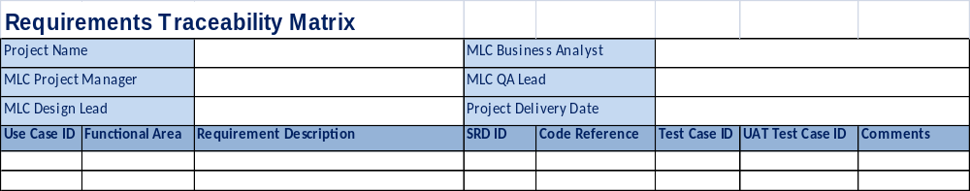
Figure 3: Requirements Traceability Matrix

Requirements are tracked from originating use case to the SRD, the component, module or code implementing each requirement, and mapped to the test case(s) that verify the implementation. This allows forward traceability to the final disposition of each requirement, and backwards traceability to the source requirement of each system function. A copy of the requirements traceability matrix can be found on the TO12 Project Site.

Context Diagrams
Contexts diagrams are modeling artifacts created to show the system at a high-level. Context diagrams are used to communicate to the MRAP customer regarding data interfaces that must occur.

Contexts diagrams show the high-level system as a whole. Using these diagrams, the reader can see interactions with other systems, and components within the system. A context diagram will be used to describe IWM for interaction with other systems, clearly defining external system interfaces. A sample context diagram is shown in Figure 4.

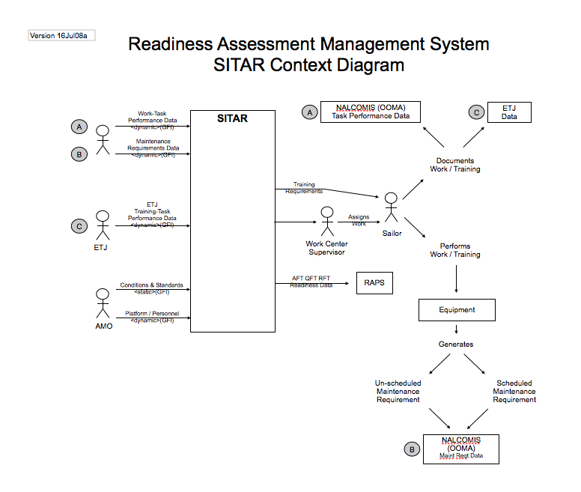

Figure 4: Context Diagram Example

System Use Case Diagrams
System use case diagrams describe the relations between many individual use cases, and are used to capture the high-level requirements. These diagrams change as use cases are refined and added. Use case diagrams help the MRAP customer understand the overall structure of the system behavior and allow identification of logical grouping. The use cases and other modeling artifacts are included in the Software Requirements Document.

An example use case diagram is shown in Figure 5.
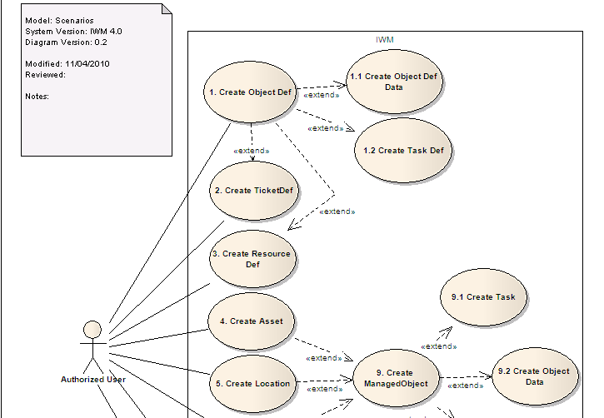

Figure 5: Use Case Diagram Example

Screen Mockups
Screen mockups are generated for each use case that describes user interaction with the system. These screen mockups are developed in collaboration with the MRAP customer, as well as reviewed and approved alongside other requirements artifacts as part of ongoing user acceptance activities. A sample screen mockup is shown in Figure 6.

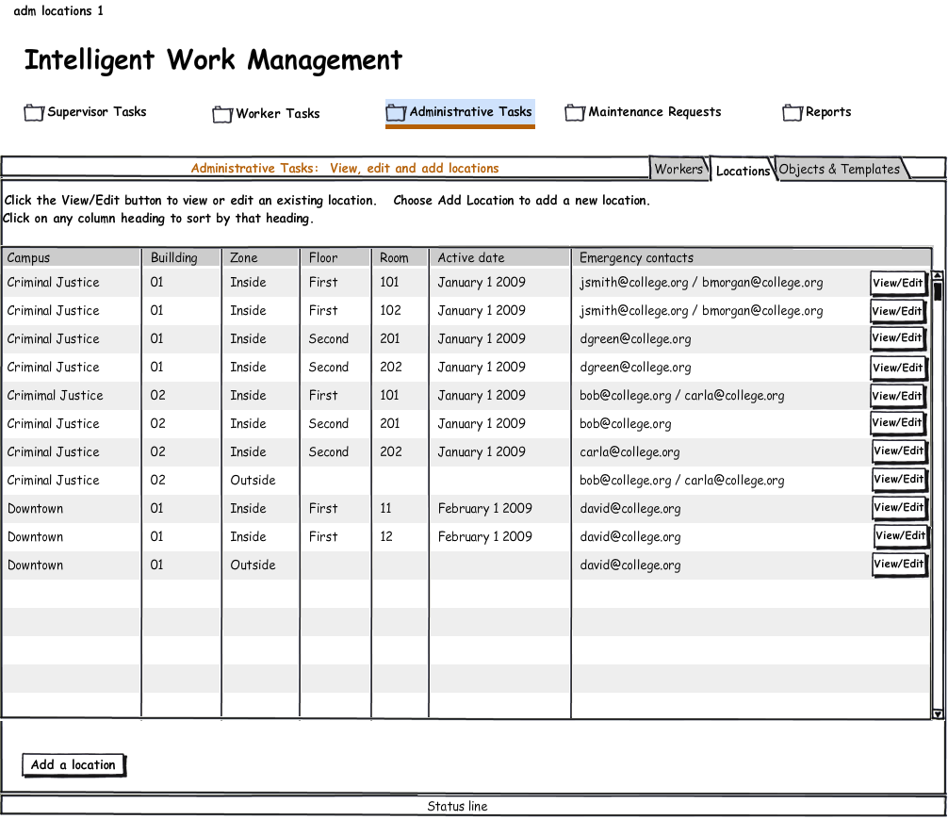
Figure 6: Screen Mockup Example

Domain Object Model
MLC works with the MRAP customer to identify core vehicle maintenance concepts in order to produce the domain object model. Using this artifact, the logical entities of the system are defined, and the behavior of the system is accomplished through processes which utilize these objects. This artifact helps ensure that MLC and the MRAP client have identified the real-world elements – personnel, equipment, etc. – that form the core of the MRAP vehicle maintenance processes.

The domain model helps build a common view of the domain across team participants. These object models are developed, reviewed and approved with the MRAP customer for acceptance alongside other requirements artifacts, as part of ongoing user acceptance activities.

Design and Coding
Unified Modeling Language (UML) design methods will be used during the design phase of the TO12 project. UML is the standard methodology for analysis and design of object-oriented systems.

Elements of the UML methodology that will be used in the design of the enhancements to IWM for MRAP vehicle maintenance are described below.

Design Object Model
The design-level object model expands on the object identified in the domain object model. Design patterns and support classes are introduced into the design object model. For each class, the set of attributes is converted into language-specific constructs and operations on each class are defined as class methods.

Design object models are used internally by the MLC development team to capture the classes that will be coded into the system.

Sequence Diagrams
Sequence diagrams are used to capture the ﬂows between systems and objects. Sequence diagrams are also used in design to describe user interactions with the system.

The design object model is used in conjunction with the use cases to produce sequence diagrams: each diagram shows the interactions of design objects, including the messages and data passed between them that are used to accomplish the behavior specified in the use case.

Sequence diagrams are used by MLC developers to closely examine the details of timing and system interactions. They will be created as needed during requirements analysis and design.

State Diagrams
State diagrams are used to describe life-cycles for specific objects. They are used when an object goes through a discrete number of states or phases, and the transition from state to state is accomplished by changes to the value or attributes of that object. These internal transitions are important elements to system behavior, and state diagrams help MLC developers completely define those object life-cycles.

Coding will be done in the Java programming language – a platform independent, object-oriented, and compiled language. The Java standard for application development for systems like IWM TO12 is called Java Enterprise Edition (JEE). JEE defines the structure, tools, services, and environment for enterprise-class systems.

The MLC TO12 project team will follow the JEE standard and “best practices” in design pattern usage in writing the code to implement the system.

Tools
Subversion
Subversion is the code versioning system that will be used for software configuration management during TO12. All IWM development work products, such as source code, configuration files, and libraries, are stored in the IWM Subversion repository. Subversion maintains a change history for each file stored within it, and allows files to be grouped or labeled together to represent a build.

TO12 application development is in the trunk, branches are made for stable versions. Testing scripts are contained in the same repository; all testing material is available to every developer.

For security management, access to the IWM Subversion repository is restricted to MLC development team personnel.

More information about Subversion may be found at: http://subversion.apache.org/.

Microsoft Project
Microsoft Project is the standard tool for creating and management project plans. MLC will deliver the IWM TO12 project work plan (PWP) in Microsoft Project format.

Status tracking on project tasks and modifications to tasks or dates will be captured in the PWP. The current PWP will be kept on the TO12 Project Site (see “TO12 Project Site” below).

Trac
Trac is a web-based tool used internally by the MLC development team to track requirement artifacts, defects, and issues. Trac has an integrated wiki and ticketing system and is integrated with the IWM subversion repository. When commits are made with references to defects or issues in the commit comments, those defects or issues are automatically updated, adding the commit comments to a defect or issue and/or marking the defect or issue as ready to be retested.

For security management, Trac access is limited to MLC project personnel. The TO12 Project site, below, describes the external site set up to track the project and house project deliverables and artifacts created during each phase of the software development cycle.

More information about the Trac tool may be found here: http://trac.edgewall.org/.

TO12 Project Site
The TO12 Project Site is an external web site which allows Sonalysts and the government to access relevant material concerning the TO12 project. All project deliverables will be posted to this site as they are finalized.

Access to the TO12 Project Site is restricted to Sonalysts and MLC TO12 project team personnel. Site access permission may be obtained from the MLC TO12 Support/QA Lead, Chris Duffy: chris@masterlinkcorp.com.

The TO12 Project Site is located at: https://staff.masterlinkcorp.com/to12/.

Backup and Archiving
The above tools, code repository and databases are stored on a volume that is backed up incrementally, on an hourly basis, to a mirrored drive. The mirror is synced off site in a nightly process.

Configuration Management Plan
Configuration management preserves previous versions of work product in order to maintain product integrity. All analysis/design, code, and test artifacts are under version control in their respective repositories.

Analysis/Design
Documentation and models capturing analysis and design work are stored on the TO12 Wiki, enabled by the Trac tool. A project layout has been defined for the project phases – Analysis, Design, Code, and Test – and the Microsoft Word or Excel documents and images capturing modeling diagrams are uploaded there. Trac offers automatic versioning for stored files – when a file with the same name as a document already in Trac is uploaded, Trac saves the file as a new version, incrementing the version number. All versions of the same file are preserved in Trac.

Code
Code artifacts are kept in Subversion, which manages versioning on individual files as well as specifying file groups which represent an application.

Java class files, XML configuration files, code libraries, and other files which comprise the application are stored, versioned and managed in Subversion.

Test
The Test Plan is stored on the TO12 Wiki with the project documentation. Test scripts and the automated testing framework are stored in Subversion as part of the code artifacts.

Testing
There are four testing efforts that will occur within the TO12 software development process: Unit tests, Agent testing, System testing, and User Acceptance Testing. Unit testing occurs with code implementation. Agent testing is its own effort, and begins once the Test Bed is complete. System testing occurs in the sprint following new functionality, and User Acceptance Testing occurs as new functionality is made visible to the user. Defect resolution occurs in all testing phases.

Unit Testing
Developers will write their own unit tests, which cover the code that is being written. These tests must pass before the code will be submitted to Subversion. Programmers will be free to write the tests before the code (Test driven development) or, when appropriate, after the code. These unit tests must pass before the code is submitted to subversion

Agent Testing
Due to IWM's nature, special tests must be created for the Agents. For this round of development, enhancements are being made to the Scheduler, there are some model changes which will likely affect all the Agents, and a message channel is being added. In order to properly test these changes, a Scheduler Test bed is being built, which will allow for not only functionality testing, but many different experimental algorithms to be tested against one another. The testbed itself will be code checked into Subversion, along with data sets used. Testing results will be contained on the wiki.

System Testing
The overall system testing will be automated. Test cases and automation scripts are developed in concert with code, and follow the same two-week sprint structure. At the end of each sprint in which code is developed, the code is compiled to create a “build” and testing is performed against the build during the following sprint.

Builds are also compiled and run nightly for a build integrity check and automated regression testing. This allows errors to be identified close to their time of introduction into the code base.

User Acceptance Testing
These test cases are designed to verify the system from the end business users’ perspective. The end users or a knowledgeable business liaison group member will perform this testing. The user testing will be done with staff and at a location mutually agreed upon with the MRAP customer, the government customer, Sonalysts, and MLC.

Defect Resolution
The automation scripts will be checked into Subversion, and run against nightly builds of IWM. Errors uncovered during the nightly regression test generate a report of the test run and is sent to QA Lead and team and logged in the Trac ticketing System.

When a defect is reported, links directly to the test case wiki page can be placed on the defect report. The test case wiki page contains both the test case, which allows the developer to recreate the defect manually, and the information needed for the developer to run the automation script. The automation scripts and control database are checked into Subversion. From there, the defect ﬂows through the defect resolution process, which is an Accept -> Assign -> Fix -> Test -> Close.

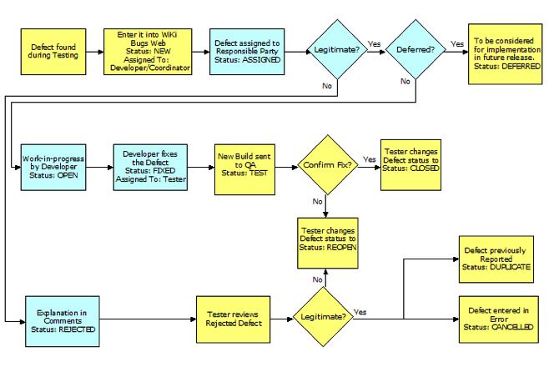
Figure 7: Defect Resolution Workflow Diagram

The System Test Strategy and System Test Plan documents detail the approach to testing for TO12 and how testing will be done. Further details may be found therein.

Appendix A – Risk List

Risk Item | Consequence | Likelihood (1-10 scale) | Priority (1-10 scale) | Impact | Mitigating Action | Responsible Party | Completion Date | Action Status
Timely Site Visit | Inability to capture specific user requirements on UI or work process | 5 | 10 | 50 | Utilize Sonalysts SME Phil McKenzie to extract first cuts at UI and work maintenance process | Mike Peter, Phil McKenzie, Steve Francis | 2/20/2011 | Open
Scheduler technology migration | Failure to produce a scheduling component that will handle resources | 3 | 10 | 30 | Scheduler prototype to develop the core scheduling capability | Mike Peter, Ken Levine | 2/28/2011 | Open

